DRDC Human Research Ethics Committee (HREC) Research Protocol
Protocol #: 2025-xxx
Title: Self/Other Evaluations Across Time Perspectives.
Principal Investigator: Dr. David R. Mandel – DRDC TRC
Co-Investigator: Irina Levit – DRDC TRC
Research Assistants:
DRDC Portfolio/Project: AC2I_031 Accelerate Command, Control, and Intelligence Project Activity (Enhanced Indications and Warnings)
Executive Summary
Background: The end-of-history illusion (EOHI) is the tendency to underestimate the magnitude of future personal change. Specifically, it has been demonstrated in previous research that people believe they have changed much more from the past to the present than they will from the present to a future time of equal distance (Quiodbach et al., 2013). For instance, in one study, when it comes to personality, values, and preferences, adults reported that they changed in the past with respect to these domains, but they reported that moving forward, they will remain the same across these domains as their current selves (Quoidbach et al., 2013). Our initial interest in the EOHI was to assess its value as a predictor of judgment calibration (Protocol 2024-042) and whether the effect changes as a function of temporal distance from the present (Protocol 2025-015). Both studies showed a positive EOHI effect. The present study will test whether the EOHI effect is generalizable to perspective taking of a closely known person.

Research Objective: The present research will test the sensitivity of EOHI when comparing perspective-taking (reporting for themselves vs reporting for someone else). Research from previous protocols (2024-042 and 2025-015) showed a positive EOHI effect when replicating past research (Quiodbach et al., 2013) and when analyzing change at 5 and 10 years from present. Gutral, Cypryanska, & Nezlek (2022) found that participants rated others’ change in personality traits from past to present and from present to future similarly to changes in their own personality traits across the time frames. Their results may be qualified by a contamination effect, where participants may have rated change in personality of others similar to their own because of the proximity of questions related to personality for other and self. We therefore extend on previous work by expanding the EOHI domains being tested (adding preferences and values in addition to personality) and implementing a between subjects design to reduce risk of contamination. In addition to the individual measures incorporated in past protocols (Cognitive Reflection Test and Actively Open-Minded Thinking), we will also implement elements of the ICAR visual and verbal reasoning items for a more comprehensive assessment of good judgement attributes.
Methodological amendments are included in response to results from the previous 2 protocols (2024-042 and 2025-015) and to address requirements of this study. Results from these protocols show that the EOHI effect is more pronounced when questions are posed in relation to change from the present, as opposed to asking participants to place themselves at a particular time period in the present, past, or future. Domain general questions remain (change in preferences, personality, and values overall) but domain specific items have been amended to ensure that participants in both perspective conditions (self and other) can provide reasonable answers. Instead of requesting responses to specific items in personality and value inventories, questions were amended to reflect higher order personality traits (ex. Agreeableness) and high order values (ex: conservation). Items in the preferences domain were amended to include broad categories of preferences; instead of asking about preferences for naps and reading, participants will be asked about preferences for hobbies, for example. See Appendix A for all questions in all domains in both perspective conditions.
Participants and Procedure: 480 participants 18-73 years, fluent in English and a citizen of Canada or the US will be recruited via the Qualtrics Panels service provider. A G*Power a priori power analysis sets the minimum sample size at 436 (see Appendix B); an additional 10% (44) is added in case of unanticipated losses of participants, for a total of 480 participants. We will constrain recruitment so that roughly half the sample is male, and half is female. We focus on Canada and the US as we aim for the results of our study to be most relevant to members of Canadian defence and security community. Finally, recruitment is constrained to participants who can speak to the preferences, personality, and values of someone who they have known well for at least 5 years.
The present study has 24 counterbalanced conditions: 2 (Temporal direction: past-focus, future-focus) x 2 (temporal display order: past-future vs future-past) x 2 (perspective: self vs other) x 3 (domain: preferences, personality, values). Temporal display order and perspective will be the between-subjects variables while domain is the only repeated-measures factor. Domain display order is not of theoretical interest and serves as a counterbalancing measure to address biases with order effects. The power analysis (see Appendix B) is based on the a priori analysis of the main effect of EOHI. As with previous protocols, the display orders for the EOHI task will test 3 iterations of fixed order: 1. Preferences, personality, values; 2. Personality, values, preferences; 3. Values, preferences, personality. Participants will complete the experiment via a link to the online Qualtrics survey. As with previous protocols, participants will answer questions related to past change from present (past-focus) and future change from present (future-focus) but temporal display order will determine if participants answer questions relative to past change from present first (past-future), or future change from present first (future-past). After completing the consent procedure and the instructional manipulation checks (Oppenheimer, Meyvis, & Davidenko, 2009), participants will start the EOHI task in which participants report on present to past change and then on present to future change (or in the reversed order) for either the self (reporting on personal change) or other (reporting on change for someone they have known well for at least 5 years). Regardless of temporal display order, participants will answer domain questions in the same order for the past-focus questions as they do for the future-focus questions; for example, if a participant is answering past-focus questions in the preferences, personality, and values order, they will respond to the future-focus questions for these domains in the same order (preferences, personality, and then values). Regardless of temporal or domain display order, participants will always complete the domain-specific items first and then the domain general item for each domain. The display order of the domain-specific items will be randomized to address issues with display order effects. Following the core task of the EOHI, participants will complete 3 individual difference measures (Cognitive Reflection Test, Actively Open-Minded Thinking, and the ICAR visual and verbal reasoning test). The study will take approximately 20 minutes to complete.
Risks and Risk Mitigation: This is a minimal-risk study. The risks involved are comparable to those experienced when working in an office environment (i.e., you may experience some mild fatigue and eyestrain from working on a computer).
Benefits and Military Significance: Participants may benefit from the experiment by gaining insight into their own thought processes. The principal benefits of the research are aimed at the Canadian intelligence community which is routinely tasked with making calibrated probabilistic assessments about past, present and future events. Understanding temporal influences on perceived change will inform how temporal perspective can bias human judgment. To the extent that it is, this also benefits all Canadians through improved defence and national security. This research also contributes directly to the North Atlantic Treaty Organization (NATO) Systems Analysis and Studies (SAS) Panel Research Task Group (RTG) 189 on Anticipatory Intelligence, which is co-chaired by the principal investigator. Anticipatory intelligence routinely involves the generation of calibrated judgments about the future and this research will inform how temporal perspective influences judgment.

DRDC Human Research Ethics Committee Submission
Protocol #: 2025-015
Title: Self/Other Evaluations Across Time Perspectives
Principal Investigator: Dr. David R. Mandel – DRDC TRC
Co-Investigator: Irina Levit – DRDC TRC
Research Assistants:
DRDC Portfolio/Project: AC2I_031 Accelerate Command, Control, and Intelligence Project Activity (Enhanced Indications and Warnings)
ACRONYMS:
DRDC – Defence Research and Development Canada
NATO – North Atlantic Treaty Organization
TRC – Toronto Research Centre
EOHI – End of History Illusion
Background:
The end-of-history illusion (EOHI) is the tendency to underestimate the magnitude of future personal change. Specifically, it has been demonstrated in previous research that people believe they have changed much more from the past to the present than they will from the present to a future time of equal distance (Quiodbach et al., 2013). For instance, in one study, when it comes to personality, values, and preferences, adults reported that they changed in the past with respect to these domains, but they reported that moving forward, they will remain the same across these domains as their current selves (Quoidbach et al., 2013). Critically, adults’ reports on how much they have changed in the past is seemingly accurate: when comparing adults’ responses to a personality survey today and their reported responses to the same survey as if they were 10 years in the past, the magnitude of the difference was similar to the actual difference across surveys taken 10 years apart (Lachman & Weaver, 1997; Quoidbach et al., 2013), This seems to suggest that adults tend to believe in stability in their future selves and underestimate how much they will change in the future (Renault et al., 2016).
One possibility for why adults may be underestimating future change could be because compared to thinking about the past (i.e., reporting change), imagining the future (i.e., predicting change) requires more effort and the sense of difficulty adults experience when trying to imagine the future, it may lead adults to misconstrue the difficulty of imagining future change with stability in the future (Schwartz, 1992; Tversky & Kahneman, 1973; Quiodbach et al., 2013). A second possibility is that adults may consider the current version of themselves in a more positive light therefore hold the belief that their future self will remain unchanged compared to the current self and their preferences, values, personality, and life-satisfaction may remain stable as a result of that (Sedikides & Alicke, 2012).
Our initial interest in the EOHI was to assess its value as a predictor of judgment calibration (Protocol 2024-042) and whether the effect changes as a function of temporal distance from the present (Protocol 2025-015). Both studies showed a positive EOHI effect. The present study will test whether the EOHI effect is generalizable to perspective taking of a closely known person.
Research Objective:
The present research will test the sensitivity of EOHI when comparing perspective-taking (reporting for themselves vs reporting for someone else). Research from previous protocols (2024-042 and 2025-015) showed a positive EOHI effect when replicating past research (Quiodbach et al., 2013) and when analyzing change at 5 and 10 years from present. Gutral, Cypryanska, & Nezlek (2022) found that participants rated others’ change in personality traits from past to present and from present to future similarly to changes in their own personality traits across the time frames. Their results may be qualified by a contamination effect, where participants may have rated change in personality of others similar to their own because of the proximity of questions related to personality for other and self. We therefore extend on previous work by expanding the EOHI domains being tested (adding preferences and values in addition to personality) and implementing a between-subjects design to reduce risk of contamination. In addition to the individual measures incorporated in past protocols (Cognitive Reflection Test and Actively Open-Minded Thinking), we will also implement elements of the ICAR visual and verbal reasoning items for a more comprehensive assessment of good judgement attributes.
Methodological amendments are included in response to results from the previous 2 protocols (2024-042 and 2025-015) and to address requirements of this study. Results from these protocols show that the EOHI effect is more pronounced when questions are posed in relation to change from the present, as opposed to asking participants to place themselves at a particular time period in the present, past, or future. Domain general questions remain (change in preferences, personality, and values overall) but domain specific items have been amended to ensure that participants in both perspective conditions (self and other) can provide reasonable answers. Instead of requesting responses to specific items in personality and value inventories, questions were amended to reflect higher order personality traits (ex. Agreeableness) and high order values (ex: conservation). Higher order values were identified from Lechner et al (2024). Higher order personality traits reflect the Big 5 personality traits (see for example Gutral et al, 2022). Items in the preferences domain were amended to include broad categories of preferences; instead of asking about preferences for naps and reading, participants will be asked about preferences for hobbies, for example. See Appendix A for all questions in all domains in both perspective conditions.
Participants:
480 participants 18-73 years, fluent in English and a citizen of Canada or the US will be recruited via the Qualtrics Panels service provider. Participant participation will be terminated for those who choose “No, I do not know such a person” when asked if there is someone that they know well for at least 5 years to the extent that they can speak to their preferences, personality, and values. A G*Power a priori power analysis sets the minimum sample size at 436 (see Appendix B); an additional 10% (44) is added in case of unanticipated losses of participants, for a total of 480 participants. We will constrain recruitment so that roughly half the sample is male, and half is female. We focus on Canada and the US as we aim for the results of our study to be most relevant to members of Canadian defence and security community. To prevent anomalies in sampling across ages, we will request a rectangular sampling distribution across bins of 18-24, 25-31, 32-38, 39-45, 46-52, 53-59, 60-66, and 67-73 years of age. As well, the rectangular sampling frame will ensure that we have comparable power across age bins to assess the EOHI effect size. This is important since EOHI has been shown to vary with age (Quoidbach et al., 2013). The EOHI effect tends to be greater for younger adults than for older adults with younger adults reporting more change in the past than older adults (Quoidbach et al., 2013).
Selection/Exclusion Criteria:
To volunteer, participants must be 18-73 years of age, Canadian and/or US citizens, and be proficient in English. English is the official working intelligence language in NATO (e.g., the probability terms stipulated for use in Allied Joint intelligence doctrine are in English) and this research is meant to inform NATO operations. Participants will also have to pass two instructional manipulation checks used to detect inattention to instructions to avoid being excluded (Oppenheimer, Meyvis, & Davidenko, 2009). Participants will be informed in the Information Sheet and Consent Form that their participation may be terminated to facilitate quotas or representation across certain demographic characteristics (such as age and sex). Participants will also be informed in both the Information Sheet and Consent Form that they are required to answer all questions to complete the study. Participants must also be able to speak to a chosen person’s preferences, personality, and values; this must be someone that they have known well for at least 5 years. Finally, participants for whom the ICAR visual reasoning questions do not display properly will also be excluded.
Procedure:
All materials are presented in Appendix A.
The present study has 24 counterbalanced conditions: 2 (Temporal direction: past-focus, future-focus) x 2 (temporal display order: past-future vs future-past) x 2 (perspective: self vs other) x 3 (domain: preferences, personality, values). Temporal display order and perspective will be the between-subjects variables while domain is the only repeated-measures factor. Domain display order is not of theoretical interest and serves as a counterbalancing measure to address biases with order effects. The power analysis (see Appendix B) is based on the a priori analysis of the main effect of EOHI. As with previous protocols, the display orders for the EOHI task will test 3 iterations of fixed order: 1. Preferences, personality, values; 2. Personality, values, preferences; 3. Values, preferences, personality. Participants will complete the experiment via a link to the online Qualtrics survey.
As with previous protocols, the display orders for the EOHI task will test 3 iterations of fixed order: 1. Preferences, personality, values; 2. Personality, values, preferences; 3. Values, preferences, personality. Participants will complete the experiment via a link to the online Qualtrics survey. As with previous protocols, participants will answer questions related to past change from present (past-focus) and future change from present (future-focus) but temporal display order will determine if participants answer questions relative to past change from present first (past-future), or future change from present first (future-past). After completing the consent procedure and the instructional manipulation checks (Oppenheimer, Meyvis, & Davidenko, 2009), participants will start the EOHI task in which participants report on present to past change and then on present to future change (or in the reversed order) for either the self (reporting on personal change) or other (reporting on change for someone they have known well for at least 5 years). Regardless of temporal display order, participants will answer domain questions in the same order for the past-focus questions as they do for the future-focus questions; for example, if a participant is answering past-focus questions in the preferences, personality, and values order, they will respond to the future-focus questions for these domains in the same order (preferences, personality, and then values). Regardless of temporal or domain display order, participants will always complete the domain-specific items first and then the domain general item for each domain. The display order of the domain-specific items will be randomized to address issues with display order effects. Following the core task of the EOHI, participants will complete 3 individual difference measures (Cognitive Reflection Test, Actively Open-Minded Thinking, and the ICAR visual and verbal reasoning test). The study will take approximately 20 minutes to complete.
Data Analysis Plan:
The hypotheses will be tested using a combination of analysis of variance and multiple linear regression techniques. The analyses will be performed using R and SPSS.
Roles and Responsibilities of Research Team:
The Principal Investigator will design the experiment, review its implementation in Qualtrics surveys by the technical support personnel, analyze the data and disseminate the final results. The technical support personnel will assist with protocol development, programming the survey, liaising with the Qualtrics Panels provider, providing data integrity checks when data is received from the provider, and transferring the data to the Principal Investigator.
Dr. David R. Mandel: Dr. Mandel will design the experiment, review its implementation in Qualtrics surveys by the technical support personnel, analyze the data and disseminate the final results.
Mrs. Irina Levit: Mrs. Levit will assist with experiment design, protocol development, survey programming and implementation, participant recruitment, data collection and review, data analysis, and dissemination of the final results.
Potential Conflicts of Interest:
There are no conflicts of interest.
Withholding of Information:
Participants will not be made aware of the hypotheses or experimental manipulations (i.e., counterbalancing of tasks) before completing the survey, as this would compromise the experiment. The hypotheses are fully described in the debriefing, and participants are encouraged to contact investigators with additional inquiries or concerns.
Medical Screening:
Not applicable.
Physician Coverage:
Not applicable.
Risks and Risk Mitigation:
This is a minimal-risk study. The risks involved are comparable to those experienced when working in an office environment (i.e., you may experience some mild fatigue and eyestrain from working on a computer).
Anonymity and Confidentiality:
Data will be collected on the Qualtrics Panels platform. No information directly identifying participants will be included in data collection documentation, the research report, or in any publications or presentations that may result from this study. Data will be collected through online questionnaires and individual participants will not be attributable to the data. Online anonymized data will be collected through Qualtrics, a collection service that stores raw data on Canadian servers in compliance with federal law, and transferred to a network computer at DRDC TRC for analysis. Data will not be used in any reports, publications, or presentations that follow from this study in any manner that would lead to the identification of the participants. Participants will be free to drop out at any time during the study by exiting from the browser window without any prejudice, and their information will be destroyed.
Benefits and Military Significance of the Study:
Participants may benefit from the experiment by gaining insight into their own thought processes. The principal benefits of the research are aimed at the Canadian intelligence community which is routinely tasked with making past- and future-focused assessments. By learning whether human are susceptible to biases regarding past and future change, intelligence organizations can better understand how temporal focus might affect analysts’ assessments. To the extent that it is, this also benefits all Canadians through improved defence and national security. This research also contributes directly to the North Atlantic Treaty Organization (NATO) Systems Analysis and Studies (SAS) Panel Research Task Group (RTG) 189 on Anticipatory Intelligence, which is co-chaired by the principal investigator. Anticipatory intelligence routinely involves the generation of future-focused judgments and this research may contribute to doing so more effectively.
Time Commitment of Participant:
The study will take approximately 20 minutes to complete. Participants will be informed to begin study when they can dedicate 20-25 minutes in a single setting with little to no interruptions.
Participant Remuneration:
Participants will be paid through Qualtrics Panels at a rate commensurate with the complexity and time involved in the study.
References:
Baron, J., Scott, S., Fincher, K., & Metz, S. E. (2015). Why does the Cognitive Reflection Test (sometimes) predict utilitarian moral judgment (and other things)?. Journal of Applied Research in Memory and Cognition, 4(3), 265-284.
Frederick, S. (2005). Cognitive reflection and decision making. Journal of Economic perspectives, 19(4), 25-42.
Gutral, J., Cypryańska, M., & Nezlek, J. B. (2022). Normative based beliefs as a basis for perceived changes in personality traits across the lifespan. PLOS ONE, 17(2)
Lachman, M. E., & Weaver, S. L. (1997). The Midlife Development Inventory (MIDI) personality scales: Scale construction and scoring. Waltham, MA: Brandeis University, 7, 1-9.
Lechner, C. M., Beierlein, C., Davidov, E., & Schwartz, S. H. (2024). Measuring the four higher-order values in Schwartz’s theory: Validation of a 17-item inventory. Journal of Personality Assessment, 106(5), 651–664. https://doi.org/10.1080/00223891.2024.2311193
Mandel, D. R., & Kelly, M. (2024). When Half Is at Least 50%: Effect of “Framing” and Probability Level on Frequency Estimates. Journal of Behavioral Decision Making, 37(3), e2399.
Oppenheimer, D. M., Meyvis, T., & Davidenko, N. (2009). Instructional manipulation checks: Detecting satisficing to increase statistical power. Journal of experimental social psychology, 45(4), 867-872.
Quoidbach, J., Gilbert, D. T., & Wilson, T. D. (2013). The end of history illusion. science, 339(6115), 96-98.
Renoult, L., Kopp, L., Davidson, P. S., Taler, V., & Atance, C. M. (2016). You'll change more than I will: Adults’ predictions about their own and others’ future preferences. Quarterly Journal of Experimental Psychology, 69(2), 299-309.
Schwartz, S. H. (1992). Universals in the content and structure of values: Theoretical advances and empirical tests in 20 countries. Advances in experimental social psychology/Academic Press.
Tversky, A., & Kahneman, D. (1973). Availability: A heuristic for judging frequency and probability. Cognitive psychology, 5(2), 207-232.

Study Information

Study Title: Self/Other Evaluations Across Time Perspectives

Purpose: Participants will be asked to complete an online experiment where they will report on 3 domains (preferences, values, personality traits) for themselves or for someone they have known very well for at least 5 years. Participants will report on the 3 domains as aspects of the domains have changed in the past 5 years relative to the present and as the participants expect them to change 5 from now.

Participants: We are looking for civilians who are aged 18-73, proficient in English (as English is the official working intelligence language in NATO), are a citizen of the US or Canada, and can speak to the preferences, personality, and values of someone who they have known well for at least 5 years to participate in this study. This is a voluntary study, and you will not be disadvantaged for not participating. If you are unable to devote 20-25 minutes to completing this survey, please exit and restart when you are able to complete it in a single sitting. Please be aware that participation may be terminated to facilitate quotas or representation across certain demographic characteristics (such as age and sex). Please be aware that participants are required to answer all questions to complete the study.

Procedure: The experiment consists of one approximately 20-minute session. The experiment is accessible through the URL at the bottom of the page. The experiment contains 4 distinct sections: 1) an introduction; 2) one task measuring change across domains of preferences, values, and personality; 3) three scales designed to measure cognitive style, cognitive reflection, and general intelligence and 4) a demographics/debrief section.

Risks and Risk Mitigation: This is a minimal-risk study. The risks involved are comparable to those experienced when working in an office environment (i.e., you may experience some mild fatigue and eyestrain from working on a computer).

Privacy: Participants’ responses will remain anonymous and confidential and will be analyzed in the aggregate along with others who respond to this task.

Location: This study can be completed at your workstation, at home, or in an office-like environment. We do not recommend completing this study on a cell phone or mobile device.

Point of Contact: If any participants have questions or concerns please contact Dr. David R. Mandel at David.Mandel@forces.gc.ca.

Voluntary Consent Form

Title: Self/Other Evaluations Across Time Perspectives
Protocol: 2025-xxx
Principal Investigator: Dr. David R. Mandel (DRDC TRC)
DRDC Portfolio/Project: AC2I_031 Accelerate Command, Control, and Intelligence Project Activity (Enhanced Indications and Warnings)

I hereby volunteer to be a participant in the DRDC study on Self/Other Evaluations Across Time Perspectives.

In this study, I understand I will be asked to complete an online experiment where I will report on 3 domains (preferences, values, personality traits) for myself or for someone that I have known very well for at least 5 years.

I have read the instructions and have had the opportunity to ask questions of the Investigator(s). All of my questions concerning this study have been fully answered to my satisfaction. However, I may obtain additional information about the research project. Any questions about this study can be answered by contacting Dr. David R. Mandel at David.Mandel@forces.gc.ca.

I have been told that I will be asked to participate in this study for approximately 20 minutes. It is recommended that I begin the study when I am able to do so with little to no interruptions in one sitting. I will be asked to participate in the Self/Other Evaluations Across Time Perspectives study. I understand that this study should be completed in a single sitting. I understand that if I am unable to devote 20-25 minutes to complete this study, I will exit the survey and restart when I am able to complete it in a single sitting.

I understand that I am free to refuse to participate in this study and may withdraw my consent without prejudice, hard feelings, or negative outcomes at any time before, during, or after the study. To withdraw during the study, participants can close the browser window and will be redirected to the end of the survey. Should I withdraw my consent, my participation in this research project will cease immediately, unless the Investigator(s) determine that such action would be dangerous or impossible (in which case my participation will cease as soon as it is safe to do so).

I also understand that the Investigator(s), or their designate, may terminate my participation at any time, regardless of my wishes. I understand that my participation may be terminated to facilitate quotas or representation across certain demographic characteristics such as sex and age. I understand that if I choose to participate, I will be required to answer all questions to complete the study.

I have been told that the risk associated with this research protocol is minimal.

Unforeseen Risk: Also, I acknowledge that my participation in this study, or indeed any research, may involve risks that are currently unforeseen by Defence Research and Development Canada (DRDC)

I understand that the information and data collected from me will be kept confidential. My name will not be included anywhere in the data files, other than this consent form. All electronic data will be stored on the investigators' work computers, which are password protected. Any hard copies that may be produced will be stored in locked cabinets and only the investigators will have access to these files.

I understand that my data will be protected under the Government Security Policy (GSP) at the appropriate designation and not revealed to anyone other than the DRDC-affiliated Investigator(s) without my consent except as data unidentified as to source.

I understand that my name will not be identified or attached in any manner to any publication arising from this study. I also understand that my data will only appear in publications in an anonymized form, such that my identity and personal information cannot be inferred. Moreover, I understand that the experimental data may be reviewed by an internal or external audit committee with the understanding that any summary information resulting from such a review will not identify me personally.

I understand that, as a Government Institution, DRDC is committed to protecting my personal information. However, under the Access to Information Act, copies of research reports and research data (including the database pertaining to this project) held in Federal government files, may be disclosed. I understand that prior to releasing the requested information, the Directorate of Access to Information and Privacy (DAIP) screens the data in accordance with the Privacy Act in order to ensure that individual identities (including indirect identification due to the collection of unique identifiers such as rank, occupation, and deployment information of military personnel) are not disclosed.

I understand that my data from this study may be used in de-identified form in future related studies provided review and approval, where appropriate, have been given by DRDC Human Research Ethics Committee. Notably, no personal identifying information will be attached to any secondary use of data.

I understand that by selecting yes and clicking continue I have not waived any legal rights I may have as a result of any harm to me occasioned by my participation in this research project beyond the risks I have assumed.

Also, I understand that I am encouraged to save a copy of this consent form–using a method such as ‘Save Page’, ‘Print to PDF’, or screenshotting as applicable to my current browser and operating system–and that I may contact any of the above-mentioned individuals at any time in the future should I wish.

Should I have any questions or concerns regarding this project before, during, or after participation, I understand that I am encouraged to contact the appropriate DRDC research centre cited below. This contact can be made by surface mail or by email to any of the DRDC addresses or individuals listed below:

Defence R&D Canada - Toronto 1133 Sheppard Avenue West Toronto, Ontario, M3K 2C9
Principal Investigator or Principal DRDC Investigator: Dr. David Mandel, David.Mandel@forces.gc.ca.

For research ethics issues: Chair, DRDC Human Research Ethics Committee (HREC), contact by email: HREC-CEESH-Toronto@drdc.rddc.gc.ca.

Appendix A: Survey Questions

Background & Consent

Please confirm that you wish to continue with this survey:
- Yes - I want to proceed with this survey.
- No - I would like to withdraw from this survey.

IMC_1
Sports Activities You Engage in Regularly

Most modern theories of decision making recognize the fact that decisions do not take place in a vacuum. Individual preferences and knowledge, along with situational variables, can greatly impact the decision process. In order to facilitate our research on decision making we are interested in knowing certain factors about you, the decision maker. Specifically, we are interested in whether you actually take the time to read the directions; if not, then some of our manipulations that rely on changes in the instructions will be ineffective. So in order to demonstrate that you have read the instructions, please ignore the sports items below. Instead, simply click the arrow to proceed to the next screen. Thank you very much.

▢ skiing (1)
▢ soccer (2)
▢ snowboarding (3)
▢ running (4)
▢ hockey (5)
▢ football (6)
▢ swimming (7)
▢ tennis (8)
▢ basketball (9)
▢ cycling (10)

IMC_2
What is two plus five?
▼ 0 (1) ... 20 (21)

Demographic Screening Questions
What is your age? Please select the age-bracket that contains your current age.
- 0 - 17
- 18 - 24
- 25 - 31
- 32 - 38
- 39 - 45
- 46 - 52
- 53 - 59
- 60 - 66
- 67 - 73
- 74+

What citizenship(s) do you hold? (check all that apply)
▢ American
▢ Canadian
▢ European
▢ Mexican
▢ Other

With respect to biological sex, are you -
- Male
- Female
- Prefer not to say

Are you fully fluent in one or more of the following languages? (please check all that apply)
▢ Cantonese
▢ English
▢ French
▢ Mandarin
▢ Spanish
▢ Other

Core tasks: the questions below constitute the core tasks of the experiment. Participants will be randomized into one of 3 groups (display order of domains) and one of two perspectives (self vs other). Within each group, participants will have domains presented in a fixed order throughout both temporal conditions. Within each perspective, participants will answer domain related questions based on their own personality/preferences/values change over the past and future 5 years, or they will answer personality/preferences/values change over the past and future 5 years for someone that they have known for at least 5 years. For each domain, participants will answer domain-specific questions (in a randomized order), and then a domain general question. Participants are also randomized into one of 2 temporal display orders (display order of past change vs future change first).

[Questions for SELF Perspective]

In the task that follows, you will be answering questions related to your preferences, personality, and values (not necessarily in this order). You will be answering how aspects of your preferences, personality, and values may be similar or different compared to how they were 5 years ago and how you expect them to be 5 years from now (not necessarily in this order).

Note: all questions are answered using the following slider scale
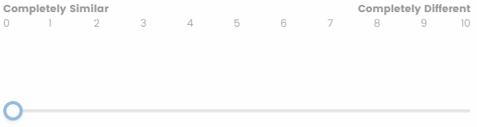

[Preferences - Past]

For each of the following statements, please indicate how similar or different your current preferences are compared to what they were 5 years ago, where 0 represents completely similar preferences then compared to now, and 10 represents completely different preferences then compared to now.

Note: the following questions will have their display order randomized.

How similar or different are your current hobbies compared to what they were 5 years ago?
How similar or different is your current musical taste compared to what it was 5 years ago?
How similar or different is your current dressing style (what you like to wear) compared to what it was 5 years ago?
How similar or different is your current preference in physical activity (type, intensity, and/or frequency) compared to what it was 5 years ago?
How similar or different is your current preference in food or cuisine compared to what it was 5 years ago?
How similar or different is your current preference for how you spend time with friends (activities, frequency, duration) compared to what it was 5 years ago?

Note: the following question always appears last in this block on a separate page

Thinking about your preferences in general, how similar or different are your preferences overall compared to what they were 5 years ago?

[Personality - Past]

For each of the following statements, please indicate how similar or different your current personality is compared to what it was 5 years ago, where 0 represents completely similar personality then compared to now, and 10 represents completely different personality then compared to now.

Note: the following questions will have their display order randomized.

How similar or different is your current tendency to try new things and be creative and imaginative compared to what it was 5 years ago?
How similar or different is your current tendency to be dependable, organized, and disciplined in pursuing goals and fulfilling personal responsibility compared to what it was 5 years ago?
How similar or different is your current tendency to enjoy social interaction and external stimulation compared to what it was 5 years ago?
How similar or different is your current tendency towards cooperation, showing compassion, and willingness to prioritize the needs of others compared to what it was 5 years ago?
How similar or different is your current tendency to react to stressful situations with negative emotions (such as anxiety or irritability) compared to what it was 5 years ago?

Note: the following question always appears last in this block on a separate page

Thinking about your personality in general, how similar or different is your personality overall compared to what it was 5 years ago?

[Values – Past]

For each of the following statements, please indicate how similar or different your current set of values are compared to what they were 5 years ago, where 0 represents completely similar values then compared to now, and 10 represents completely different values then compared to now.

Note: the following questions will have their display order randomized.

How similar or different is your current inclination to seek independence, autonomy, and self-directed growth compared to what it was 5 years ago?
How similar or different is your current inclination to pursue personal success, achievement, and influence compared to what it was 5 years ago?
How similar or different is your current inclination to value tolerance and caring for others, and justice for people and nature compared to what it was 5 years ago?
How similar or different is your current inclination to value having close-knit relationships with family members and friends compared to what it was 5 years ago?
How similar or different is your current inclination to value having a lot of connections, associations, and interactions with people compared to what it was 5 years ago?

Note: the following question always appears last in this block on a separate page

Thinking about your values in general, how similar or different is your current set of values overall compared to what it was 5 years ago?

[Preferences – Future]

For each of the following statements, please indicate how similar or different your current preferences are compared to what you expect them to be 5 years from now, where 0 represents completely similar preferences now compared to 5 years in the future, and 10 represents completely different preferences now compared to 5 years in the future.

Note: the following questions will have their display order randomized.

How similar or different are your current hobbies compared to what you expect them to be 5 years from now?
How similar or different is your current musical taste compared to what you expect it to be 5 years from now?
How similar or different is your current dressing style (what you like to wear) compared to what you expect it to be 5 years from now?
How similar or different is your current preference in physical activity (type, intensity, and/or frequency) compared to what you expect it to be 5 years from now?
How similar or different is your current preference in food or cuisine compared to what you expect it to be 5 years from now?
How similar or different is your current preference for how you spend time with friends (activities, frequency, duration) compared to what you expect it to be 5 years from now?

Note: the following question always appears last in this block on a separate page

Thinking about your preferences in general, how similar or different are your preferences overall compared to what you expect them to be 5 years from now?

[Personality – Future]

For each of the following statements, please indicate how similar or different your current personality is compared to what you expect it to be 5 years from now, where 0 represents completely similar personality characteristics now compared to 5 years in the future, and 10 represents completely different personality characteristics now compared to 5 years in the future.

Note: the following questions will have their display order randomized.

How similar or different is your current tendency to try new things and be creative and imaginative compared to what you expect it to be 5 years from now?
How similar or different is your current tendency to be dependable, organized, and disciplined in pursuing goals and fulfilling personal responsibility compared to what you expect it to be 5 years from now?
How similar or different is your current tendency to enjoy social interaction and external stimulation compared to what you expect it to be 5 years from now?
How similar or different is your current tendency towards cooperation, showing compassion, and willingness to prioritize the needs of others compared to what you expect it to be 5 years from now?
How similar or different is your current tendency to react to stressful situations with negative emotions (such as anxiety or irritability) compared to what you expect it to be 5 years from now?

Note: the following question always appears last in this block on a separate page
Thinking about your personality in general, how similar or different is your personality overall compared to what you expect it to be 5 years from now?

[Values – Future]

For each of the following statements, please indicate how similar or different your current set of values are compared to what you expect them to be 5 years from now, where 0 represents completely similar values now compared to 5 years in the future, and 10 represents completely different values now compared to 5 years in the future.

Note: the following questions will have their display order randomized.

How similar or different is your current inclination to value stability, security (of self, others, and nation), tradition, and law and order compared to what you expect it to be 5 years from now?
How similar or different is your current inclination to seek independence, autonomy, and self-directed growth compared to what you expect it to be 5 years from now?
How similar or different is your current inclination to pursue personal success, achievement, and influence compared to what you expect it to be 5 years from now?
How similar or different is your current inclination to value tolerance and caring for others, and justice for people and nature compared to what you expect it to be 5 years from now?
How similar or different is your current inclination to value having close-knit relationships with family members and friends compared to what you expect it to be 5 years from now?
How similar or different is your current inclination to value having a lot of connections, associations, and interactions with people compared to what you expect it to be 5 years from now?

Note: the following question always appears last in this block on a separate page

Thinking about your values in general, how similar or different is your current set of values overall compared to what you expect it to be 5 years from now?

[Questions for OTHER Perspective]

In the task that follows, you will be asked to identify someone in your life who you have known very well for at least 5 years (either someone you like or dislike). You will be tasked with answering questions related to your chosen person's preferences, personality, and values (not necessarily in this order). You will be answering how aspects of your chosen person's preferences, personality, and values may be similar or different compared to how they were 5 years ago and how you expect them to be 5 years from now (not necessarily in this order).

Can you think of a person that you have known very well for at least 5 years, to the extent that you can speak to their preferences, personality, and values?
This can be someone that you like or dislike.
- Yes, there is a person that I know very well and can speak to their preferences, personality, and values.
- No, I do not know such a person.

How long have you known this person?
Please choose the total number of years that you have known this person really well, rounded down to the nearest whole number.

Note: responses are chosen using a dropdown menu with options ranging from “1” through “20+”.

Do you like or dislike this person?
- Dislike a great deal
- Dislike somewhat
- Neither like nor dislike
- Like somewhat
- Like a great deal

[Note: all questions that follow are answered using the following slider scale]

[Preferences - Past]

For each of the following statements, please indicate how similar or different your chosen person's current preferences are compared to what they were 5 years ago, where 0 represents completely similar preferences then compared to now, and 10 represents completely different preferences then compared to now.

Note: the following questions will have their display order randomized.

How similar or different is your chosen person's current musical taste compared to what it was 5 years ago?
How similar or different is your chosen person's current dressing style (what you like to wear) compared to what it was 5 years ago?
How similar or different is your chosen person's current preference in physical activity (type, intensity, and/or frequency) compared to what it was 5 years ago?
How similar or different is your chosen person's current preference in food or cuisine compared to what it was 5 years ago?
How similar or different is your chosen person's current preference for how you spend time with friends (activities, frequency, duration) compared to what it was 5 years ago?
Note: the following question always appears last in this block on a separate page

Thinking about your chosen person's preferences in general, how similar or different are your chosen person's preferences overall compared to what they were 5 years ago?
[Personality – Past]

For each of the following statements, please indicate how similar or different your chosen person's current personality is compared to what it was 5 years ago, where 0 represents completely similar personality then compared to now, and 10 represents completely different personality then compared to now.

Note: the following questions will have their display order randomized.

How similar or different is your chosen person's current tendency to try new things and be creative and imaginative compared to what it was 5 years ago?
How similar or different is your chosen person's current tendency to be dependable, organized, and disciplined in pursuing goals and fulfilling personal responsibility compared to what it was 5 years ago?
How similar or different is your chosen person's current tendency to enjoy social interaction and external stimulation compared to what it was 5 years ago?
How similar or different is your chosen person's current tendency towards cooperation, showing compassion, and willingness to prioritize the needs of others compared to what it was 5 years ago?
How similar or different is your chosen person's current tendency to react to stressful situations with negative emotions (such as anxiety or irritability) compared to what it was 5 years ago?
Note: the following question always appears last in this block on a separate page

Thinking about your chosen person's personality in general, how similar or different is your chosen person's personality overall compared to what it was 5 years ago?

[Values – Past]

For each of the following statements, please indicate how similar or different your chosen person's current set of values are compared to what they were 5 years ago, where 0 represents completely similar values then compared to now, and 10 represents completely different values then compared to now.

Note: the following questions will have their display order randomized.

How similar or different is your chosen person's current inclination to value stability, security (of self, others, and nation), tradition, and law and order compared to what it was 5 years ago?
How similar or different is your chosen person's current inclination to seek independence, autonomy, and self-directed growth compared to what it was 5 years ago?
How similar or different is your chosen person's current inclination to pursue personal success, achievement, and influence compared to what it was 5 years ago?
How similar or different is your chosen person's current inclination to value tolerance and caring for others, and justice for people and nature compared to what it was 5 years ago?
How similar or different is your chosen person's current inclination to value having close-knit relationships with family members and friends compared to what it was 5 years ago?
How similar or different is your chosen person's current inclination to value having a lot of connections, associations, and interactions with people compared to what it was 5 years ago?

Note: the following question always appears last in this block on a separate page

Thinking about your chosen person's values in general, how similar or different is your chosen person's current set of values overall compared to what it was 5 years ago?

[Preferences – Future]

For each of the following statements, please indicate how similar or different your chosen person's current preferences are compared to what you expect them to be 5 years from now, where 0 represents completely similar preferences now compared to 5 years in the future, and 10 represents completely different preferences now compared to 5 years in the future.

Note: the following questions will have their display order randomized.

How similar or different are your chosen person's current hobbies compared to what you expect them to be 5 years from now?
How similar or different is your chosen person's current musical taste compared to what you expect it to be 5 years from now?
How similar or different is your chosen person's current dressing style (what you like to wear) compared to what you expect it to be 5 years from now?
How similar or different is your chosen person's current preference in physical activity (type, intensity, and/or frequency) compared to what you expect it to be 5 years from now?
How similar or different is your chosen person's current preference in food or cuisine compared to what you expect it to be 5 years from now?
How similar or different is your chosen person's current preference for how you spend time with friends (activities, frequency, duration) compared to what you expect it to be 5 years from now?

Note: the following question always appears last in this block on a separate page

Thinking about your chosen person's preferences in general, how similar or different are your chosen person's preferences overall compared to what you expect them to be 5 years from now?

[Personality – Future]

For each of the following statements, please indicate how similar or different your chosen person's current personality is compared to what you expect it to be 5 years from now, where 0 represents completely similar personality characteristics now compared to 5 years in the future, and 10 represents completely different personality characteristics now compared to 5 years in the future

Note: the following questions will have their display order randomized.

How similar or different is your chosen person's current tendency to try new things and be creative and imaginative compared to what you expect it to be 5 years from now?
How similar or different is your chosen person's current tendency to be dependable, organized, and disciplined in pursuing goals and fulfilling personal responsibility compared to what you expect it to be 5 years from now?
How similar or different is your chosen person's current tendency to enjoy social interaction and external stimulation compared to what you expect it to be 5 years from now?
How similar or different is your chosen person's current tendency towards cooperation, showing compassion, and willingness to prioritize the needs of others compared to what you expect it to be 5 years from now?
How similar or different is your chosen person's current tendency to react to stressful situations with negative emotions (such as anxiety or irritability) compared to what you expect it to be 5 years from now?

Note: the following question always appears last in this block on a separate page

Thinking about your chosen person's personality in general, how similar or different is your chosen person's personality overall compared to what you expect it to be 5 years from now?

[Values – Future]

For each of the following statements, please indicate how similar or different your chosen person's current set of values are compared to what you expect them to be 5 years from now, where 0 represents completely similar values now compared to 5 years in the future, and 10 represents completely different values now compared to 5 years in the future.

Note: the following questions will have their display order randomized.

How similar or different is your chosen person's current inclination to value stability, security (of self, others, and nation), tradition, and law and order compared to what you expect it to be 5 years from now?
How similar or different is your chosen person's current inclination to seek independence, autonomy, and self-directed growth compared to what you expect it to be 5 years from now?
How similar or different is your chosen person's current inclination to pursue personal success, achievement, and influence compared to what you expect it to be 5 years from now?
How similar or different is your chosen person's current inclination to value tolerance and caring for others, and justice for people and nature compared to what you expect it to be 5 years from now?
How similar or different is your chosen person's current inclination to value having close-knit relationships with family members and friends compared to what you expect it to be 5 years from now?
How similar or different is your chosen person's current inclination to value having a lot of connections, associations, and interactions with people compared to what you expect it to be 5 years from now?

Note: the following question always appears last in this block on a separate page

Thinking about your chosen person's values in general, how similar or different is your chosen person's current set of values overall compared to what you expect it to be 5 years from now?

[SCALES & TESTS]
[buffer]

You have completed the first part of the experiment. Please click the button below to begin the next part of the experiment.

[Actively Open-Minded Thinking Scale]

Next, you will be asked to read 8 statements. For each, please respond using the 5-point scale in which -2 means that you strongly disagree with the statement and 2 means you strongly agree with it.

Note: the statements in this scale are displayed in a random order and are answered with the following scale
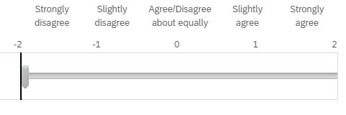
Statements:
- Allowing oneself to be convinced by an opposing argument is a sign of good character.
- People should take into consideration evidence that goes against their beliefs.
- People should revise their beliefs in response to new information or evidence.
- Changing your mind is a sign of weakness.
- Intuition is the best guide in making decisions.
- It is important to persevere in your beliefs even when evidence is brought to bear against them.
- One should disregard evidence that conflicts with one's established beliefs.
- People should search actively for reasons why their beliefs might be wrong.

Cognitive Reflection Test

On this screen, you will be asked to complete three skill-testing questions. For each, please choose the correct multiple-choice response.

On this screen, you will be asked to complete three skill-testing questions. For each, please choose the correct multiple-choice response.
- 5 cents
- 10 cents
- 15 cents
- 20 cents

If it takes 5 machines 5 minutes to make 5 widgets, how long would it take 100 machines to make 100 widgets?
- 5 minutes
- 25 minutes
- 75 minutes
- 100 minutes

In a lake, there is a patch of lily pads. Every day, the patch doubles in size. If it takes 48 days for the patch to cover the entire lake, how long would it take for the patch to cover half of the lake?
- 15 days
- 24 days
- 36 days
- 47 days

[ICAR Intelligence Test]

Instructions:
You will next be presented with a series of word problems as well as problems requiring you to complete a figure (i.e., pick the option that best fills in a missing space in a figure). In each case try to read the problem carefully and answer to the best of your ability. The problems are challenging. Please try your best.

[word problems] note: each question is displayed on a separate page.

What number is one fifth of one fourth of one ninth of 900?
- 2
- 3
- 4
- 5
- 6
- 7

Adam and Melissa went fly-fishing and caught a total of 32 salmon. Melissa caught three times as many salmon as Adam. How many salmon did Adam catch?
- 7
- 8
- 9
- 10
- 11
- 12

Zach is taller than Matt and Richard is shorter than Zach. Which of the following statements would be most accurate?
- Richard is taller than Matt
- Richard is shorter than Matt
- Richard is as tall as Matt
- It’s impossible to tell
- Richard is taller than Zach
- Zach is shorter than Matt
Joshua is 12 years old and his sister is three times as old as he. When Joshua is 23 years old, how old will his sister be?
- 35
- 39
- 44
- 47
- 53
- 57
If the day after tomorrow is two days before Thursday then what day is it today?
- Friday
- Monday
- Wednesday
- Saturday
- Tuesday
- Sunday

[matrix problems]

Note: each of the following matrix problems provides 6 possible solutions, labelled A through F. Participants are required are presented with multiple choice answer options, labelled A through F. Participants will need to choose the correct solution. Each question is displayed on a separate page.

[matrix Q#1]
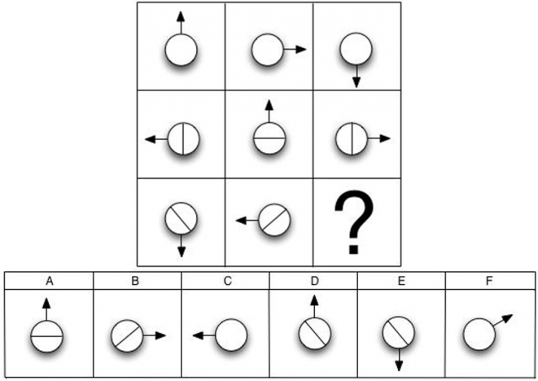

[matrix Q#2]
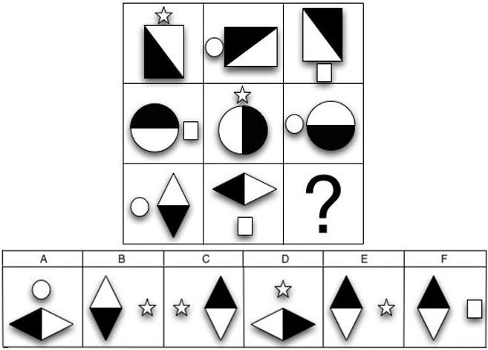

[matrix Q#3]
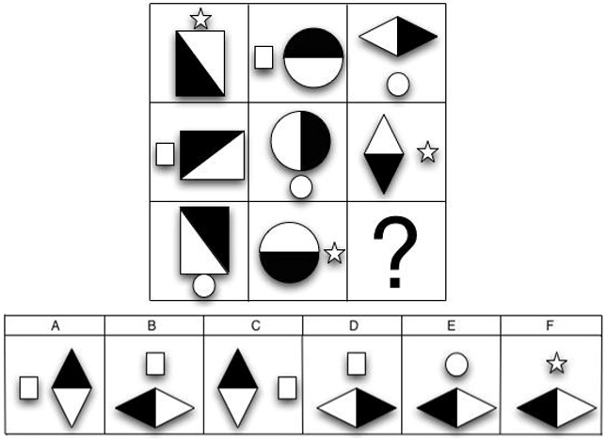

[matrix Q#4]
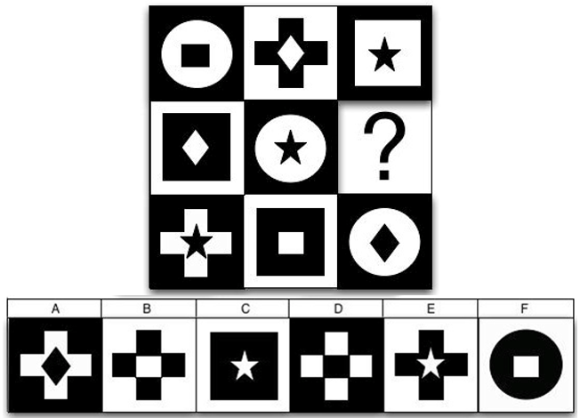

[matrix Q#5]
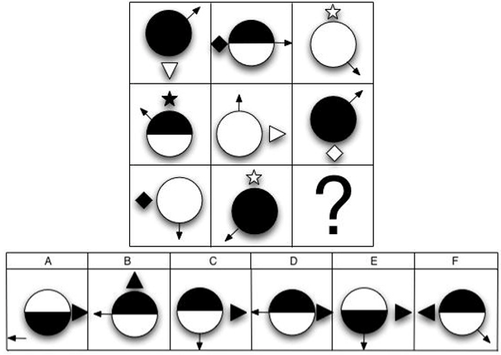

[ICAR image check] displayed on a separate page.

The previous task included questions in which you were presented with a figure and asked to pick the option, amongst several options, that best filled a missing space in the figure.
Were all figures (i.e., images) displayed properly during this task or did some figures fail to display (e.g., showed a link to a broken image)?
- All figures displayed properly
- One or more figures failed to display

[End of Survey Demographic Questions]
[buffer]

You have completed the first part of the experiment. Please click the button below to begin the next part of the experiment.

[questions]

With respect to biological sex, are you -
- Male
- Female
- Prefer not to say

What is the highest level of education that you have completed?
- High School (or equivalent)
- Trade School
- College Diploma/Certificate
- Professional Degree (ex. JD/MD)
- University - Undergraduate
- University - Graduate (Masters)
- University - PhD

How old are you (in years)?
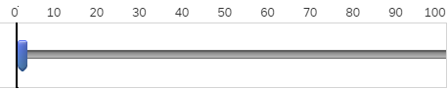

Please take a moment to share any feedback you may have about this survey. Remember - your responses will remain anonymous.
________________________________________________________________
________________________________________________________________
________________________________________________________________
________________________________________________________________
________________________________________________________________

Debrief Letter
DEBRIEF

Researchers: Dr. David R. Mandel (DRDC – TRC), Irina Levit (DRDC – TRC)
Thank you for participating in this research. Your time and effort are greatly appreciated.
This experiment examines how individuals report past change and predict future change compared to their assessments of the present on various self-relevant topics (e.g., their personality characteristics). It also looks at the effect of “the end of history illusion” (EOHI) to examine how generalizable it is to perspective-taking (reporting on domains for self or for someone else). The EOHI refers to the tendency for people to perceive more change in themselves from past to present than from present to the future (controlling for time duration, e.g., 5 years back and 5 years ahead). The purpose of the experiment is to examine how sensitive the end of history illusion is when comparing perspective-taking (reporting for myself vs reporting for someone else).
It directly contributes to the Accelerate Command, Control, and Intelligence Program Activity, which is carried out by Defence Research and Development Canada (DRDC), an agency of the Department of National Defence. Our findings will be of benefit to the Canadian Armed Forces Intelligence Community, as well as the Intelligence Community at large in Canada and amongst its NATO allies.
During the experiment, you were presented with a series of statements in the domains of preferences, values, and personality. We asked you to report on these domains with respect to relative change from now to past and from now to future. We asked you to report on these domains from either your perspective or from the perspective of someone that you have known very well for at least 5 years. We plan to use your responses to better understand the EOHI. For instance, whereas past studies have focused on the personal perspective as the sole reference point, in this study we can compare perceived personal change to perceived change for someone else. This will allow us to test various hypotheses regarding perspective taking in time-contingent judgments.
After completing the core experimental task, you answered three more sets of questions. Together, these tests will be used to evaluate whether interpretations of the different assessment formats are predicted by numeracy, verbal reasoning, visual reasoning, and a facet of your thinking style known as “actively open-minded thinking”, all of which have also been linked to better calibrated and more accurate judgments in past research.
We will use statistical tests to analyze the data provided by participants in this study. Our analyses will focus on how participants responded to questions in the aggregate. Because our focus is on the aggregate and also because the data has been anonymized, we cannot provide you with a summary of your individual pattern of response; however, Dr. Mandel can provide you with a summary of the aggregate results in due course if you contact him. In addition, if you have any questions or concerns about this research or your participation in it, then please contact Dr. Mandel at the email listed below:
Dr. David R. Mandel (DRDC-TRC),
Email: David.Mandel@forces.gc.ca

Appendix B: Power Analysis (based on main effect)

